**Announcing the Db2 LangChain Connector: An enterprise Vector Storage for Python AI workflows**



**By Shaikh Quader & Ashok Kumar**

We are pleased to announce the release of the **Db2 LangChain Connector**, an open-source Python library that brings IBM Db2 into the LangChain ecosystem. Built on top of the newly introduced vector capabilities in Db2 12 Mod Pack 2, this connector allows developers to use Db2 as a vector store within LangChain workflows.

**Empowering modern AI development**

This Python connector simplifies the development of LLM applications—such as AI agents and retrieval-augmented generation (RAG)—by using Db2 as the vector store for semantic search and many generative AI tasks. The integration addresses a critical need in the AI developers community: seamless access to enterprise-grade vector storage capabilities in Db2 through a familiar, widely-adopted Python framework.

**LangChain integration benefits**

LangChain offers a flexible framework for combining language models with tools, data sources, and vector stores to orchestrate end-to-end LLM application pipelines. The Db2 LangChain Connector extends this framework by providing a native Python interface that enables developers to

* Create tables with vector columns in Db2 through intuitive Python commands
* Insert, store and efficiently manage vector embeddings at scale
* Perform similarity search using supported distance metrics including cosine similarity, Euclidean distance and Dot product
* Leverage Db2's enterprise-grade performance, security and reliability features

All operations are supported through familiar Python workflows, making it easier to integrate Db2 into modern GenAI and Agentic AI applications without requiring database expertise.

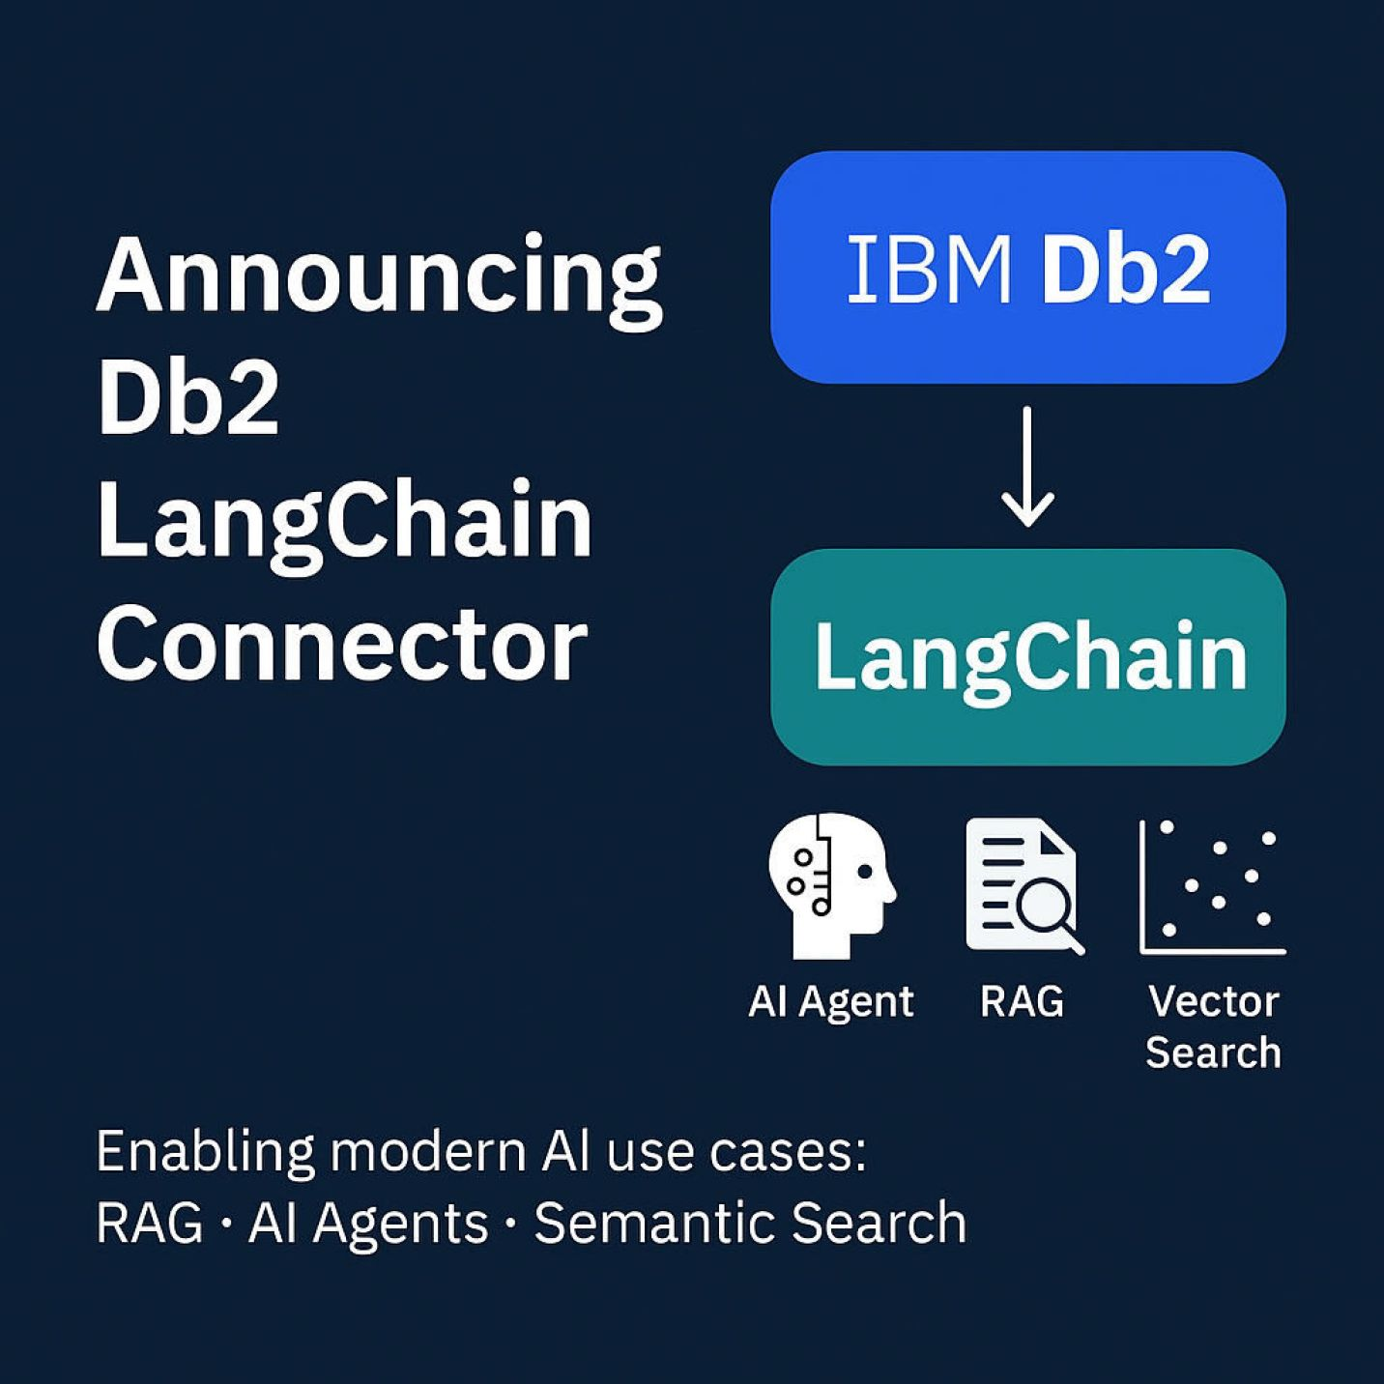

**Reducing development friction**

Our goal is to reduce friction for developers working with open, community-adopted frameworks like LangChain, while unlocking the power of enterprise-grade vector search with Db2. By providing this native integration, we enable developers to focus on building innovative AI applications rather than managing complex database configurations or custom integration code.

The connector bridges the gap between rapid prototyping and production deployment, allowing teams to start with familiar Python-based development workflows and seamlessly scale to enterprise requirements without architectural changes.

**Getting started**

The connector is available for download from PyPI using standard Python package management tools. Installation is straightforward and requires minimal configuration to begin working with Db2 vector capabilities.

To help you get started, we've published a comprehensive tutorial notebook that demonstrates how to use the Db2 LangChain Connector as part of a Python workflow. The tutorial covers common usage scenarios including document embedding, semantic search implementation and RAG pipeline construction.

This release represents our commitment to supporting the open-source AI development community while providing access to enterprise-grade data management capabilities that scale with your applications.

[View the LangChain notebook](https://github.com/langchain-ai/langchain-ibm/blob/756f43fe392f70f6c4b755d7966ea8ee1cc42759/libs/langchain-db2/docs/db2.ipynb)